Local Health Services
Nearest Hospital: Headwaters Health Care Centre
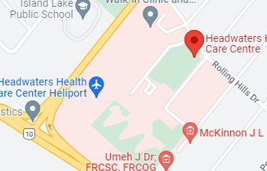
100 Rolling Hills Drive, Orangeville, On
Nearest major intersection is Highway 9 and 10
***Please check to ensure that the emergency department is open prior as we have been affected by the rolling emergency closures.
Next closest hospital is:
Stevenson Memorial Hospital
200 Fletcher Crescent
Alliston, On

Local Walk-In Clinics

Headwaters Walk In Clinic
170 Lakeview Crt Unit 2
Orangeville, On
519-307-1201

Orangeville Urgent Care Family Practice
33a Broadway
Orangeville, On
519-938-9997

5th Avenue Walk In Clinic
50 Rolling Hills Dr Unit 5
Orangeville, On
519-942-0040

Local Pharmacies

Rexall
520 Riddell Rd
Orangeville, On

Shoppers Drug Mart
489 Broadway
Orangeville, On

Shoppers Drug Mart
25 Broadway
Orangeville, On

