Emergency Action Plans

Idlewyld and Rotary North and South Parks
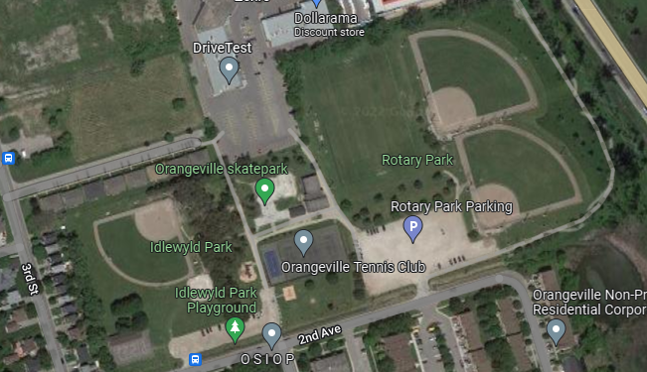

Idlewyld Park: Large Diamond
55 Second Ave
Orangeville
Closest Major Intersection: 3rd Street and 2nd Avenue

Denotes emergency access to Idlewyld field, gates will be closed but dummy locked so that they can easily be open in the event of an emergency. Town staff will also be on site for assistance.

Rotary North and South Diamonds
75 Second Ave
Orangeville
Closest Major Intersection: 3rd Street and 2nd Avenue

Denotes emergency access to Rotary North and South diamonds, gates will be closed but dummy locked so that they can easily be opened in the event of an emergency. Town staff will also be on site for assistance.

Charge Person: Designated team trainer or coach
Call Person: Orangeville Baseball Association site volunteer
Control Person: Umpires and Team Coaching staff

Emergency Steps
- Orangeville Baseball Site Volunteer needs to be on alert for injuries on the field and ready to assist charge person
- Charge person determines if 911 needs to be called
- Call Person calls 911 and gives all pertinent information as well, as diamond and location on diamond
- Control people assist charge person with keeping crowd back and gathering anything that they may require

Alton Community Diamond

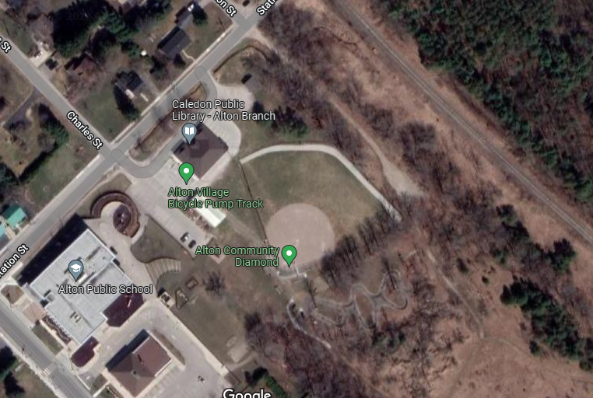
Alton Community Diamond
31 Station St
Alton, On
Closest Major Intersection: Main St and Station St

Ambulance access points, can drive in from parking lots to gain field side access

Charge Person: Designated team trainer or coach
Call Person: Orangeville Baseball Association site volunteer
Control Person: Umpires and Team Coaching staff

Emergency Steps
- Orangeville Baseball Site Volunteer needs to be on alert for injuries on the field and ready to assist charge person
- Charge person determines if 911 needs to be called
- Call Person calls 911 and gives all pertinent information as well, as diamond and location on diamond
- Control people assist charge person with keeping crowd back and gathering anything that they may require

Springbrook Shack Diamond
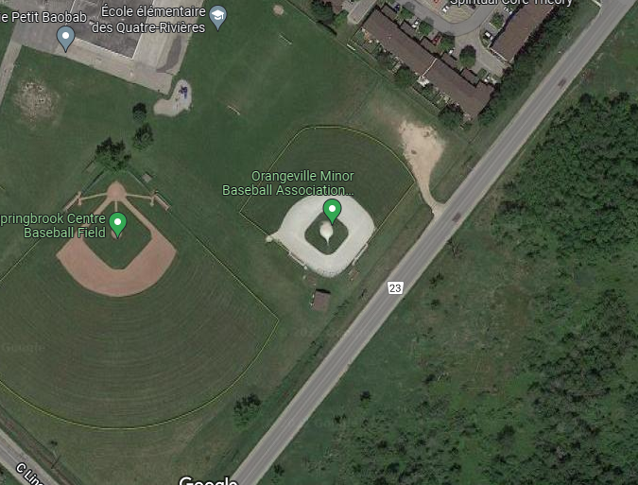
Springbrook Shack Diamond
450 Townline
Orangeville
Closest Major Intersection: C-Line and Townline

Denotes emergency access for field
Charge Person: Designated team trainer or coach
Call Person: Orangeville Baseball Association site volunteer
Control Person: Umpires and Team Coaching staff

Emergency Steps
- Orangeville Baseball Site Volunteer needs to be on alert for injuries on the field and ready to assist charge person
- Charge person determines if 911 needs to be called
- Call Person calls 911 and gives all pertinent information as well, as diamond and location on diamond
- Control people assist charge person with keeping crowd back and gathering anything that they may require

